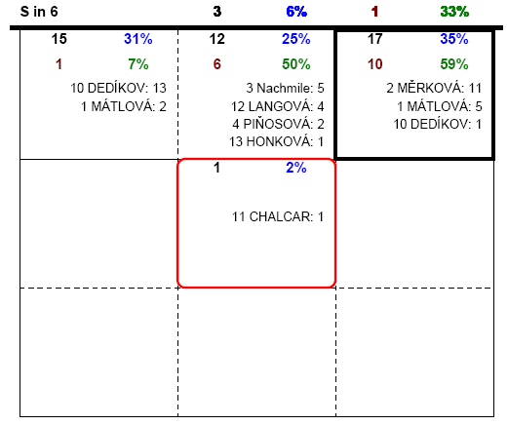
11

10

6
48%
33%
50%
ÚTLAS

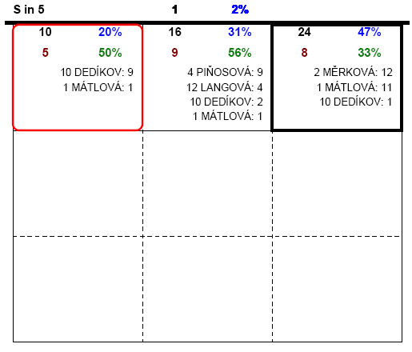
6

10

11
40%
58%
33%
SANY

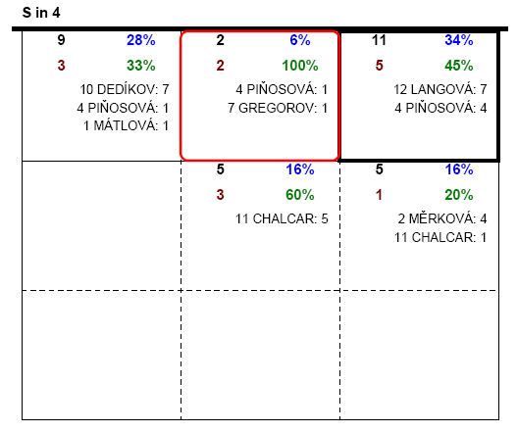
6

10

11
32%
40%
53%
SOŇA

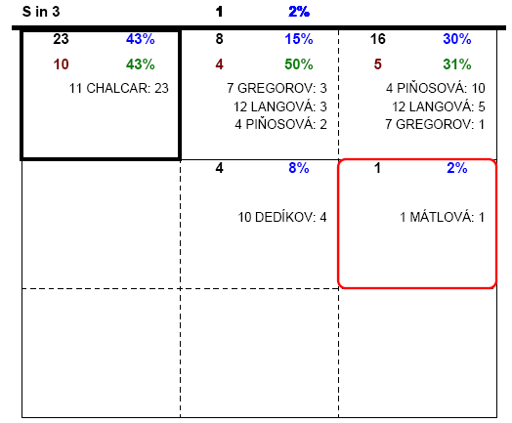
10

11

6
47%
27%
46%
MELDA

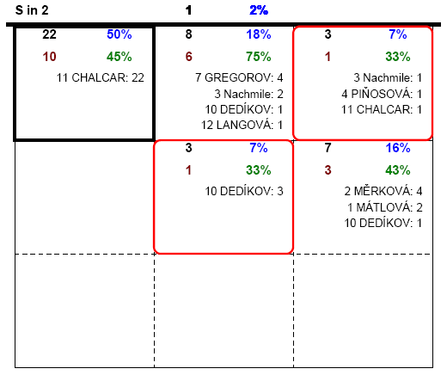
6

11

10
40%
34%
11%
BOŽA

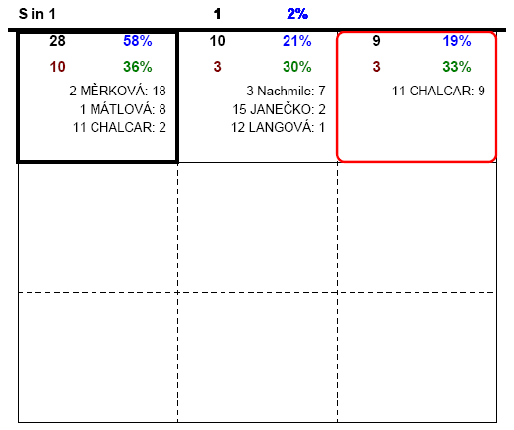
10

11

6
32%
42%
35%
ŠÁRKA

