# Pass Zones to use in datavolley program

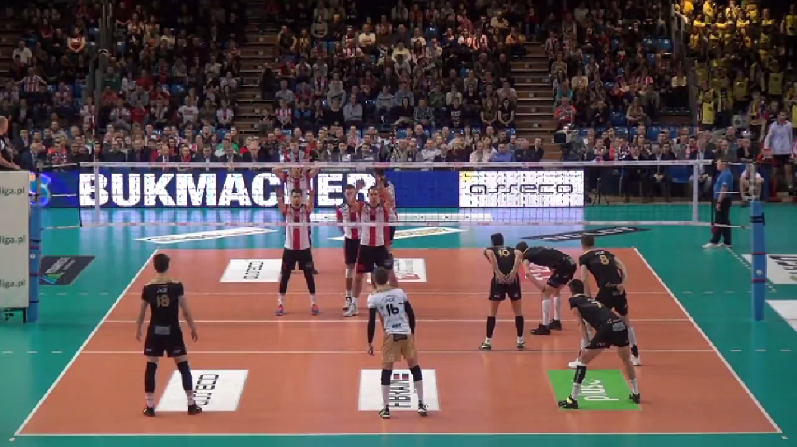

1A

9

7

1

5

6

5D

4

2

3

# Court Partition for setter calls and Block System

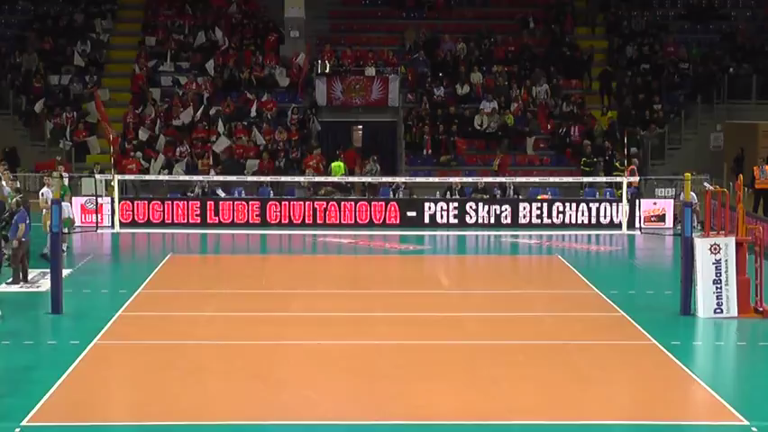

Regular

Shift to zone 2

Middle

Shift to zone 4

Shift to Z4 no 1°tempo

Shift to Z2 no 1°tempo

Regular no 1°tempo

**Regular:** In this zone setter’s calls can be: K1; K7; K2; KD

**Middle:** In this zone setter’s calls can be: KH; KX; KW; KJ

**Shift to zone 2:** In this zone setter’s calls can be: KM; KC; KA

**Shift to zone 4:** In this zone setter’s calls can be: KP; KS; KQ

**Grey zone is always without first tempo**

**Regular:** In this zone setter’s calls can be: KE

**Shift to zone 2:** In this zone setter’s calls can be: KO

**Shift to zone 4:** In this zone setter’s calls can be: KF